SAVE THE DATE!
Best of Texas, March 27th, 2020
Check back soon for the announcement of our big headliner!
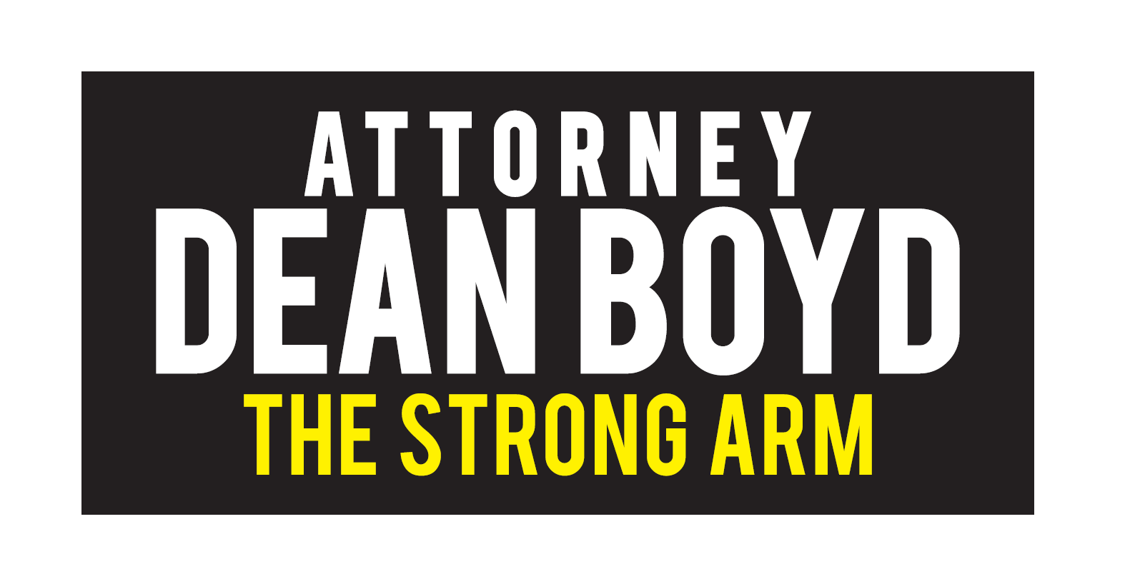
Proud Sponsor of the Junior League of Amarillo

